**LAB 6: FORMAT STRING VULNERABILITY LAB**

**Task 1: The Vulnerable Program**

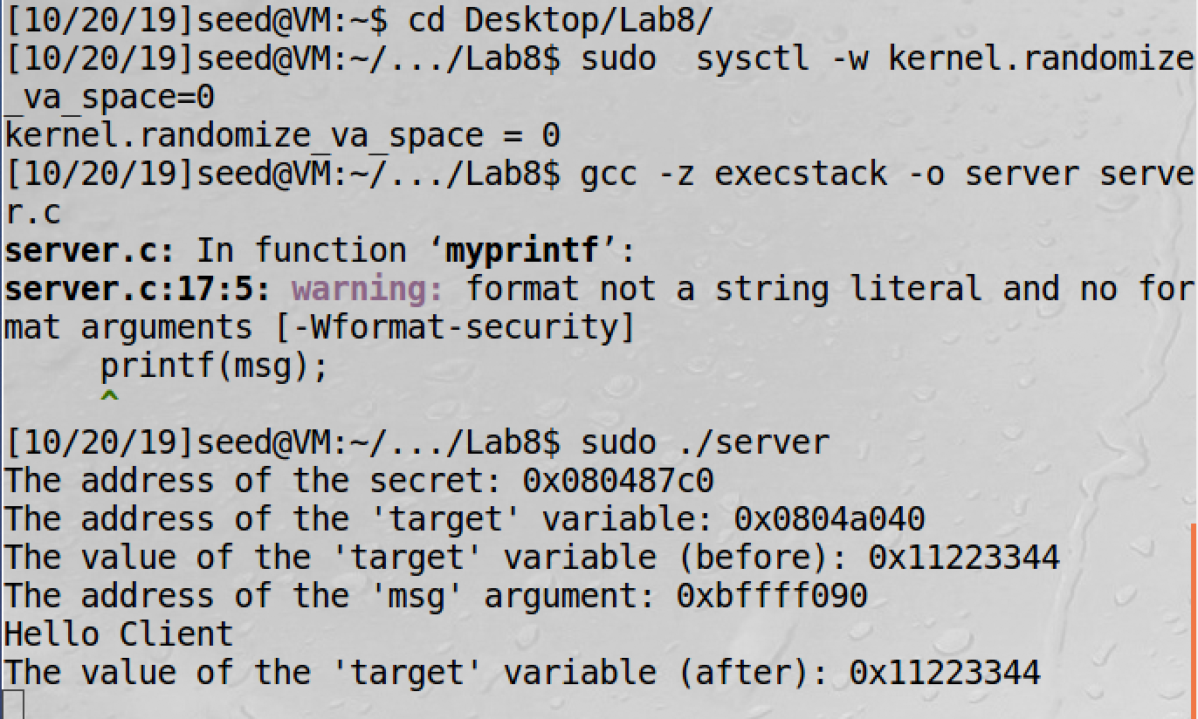

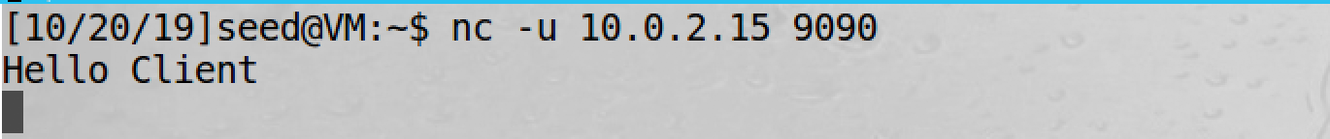

We turn off address randomization, when compiling the program it throws a warning. We run the server program in one terminal and send a hello from the client to the server which listens to port 9090.

**%Task 2: Understanding the Layout of the stack**

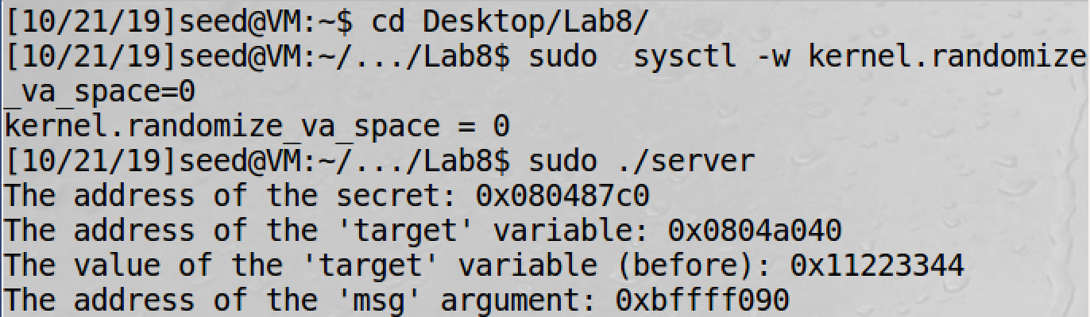

since we know the msg address we can find (2) the return address which is msg address – 4 bytes, i.e,  
bffff090 + 4 = bffff08c.



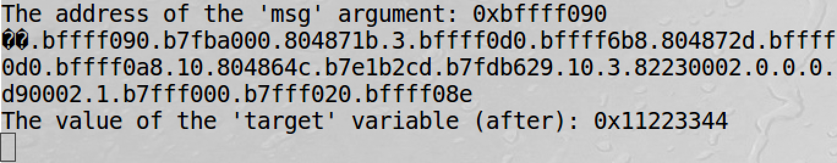



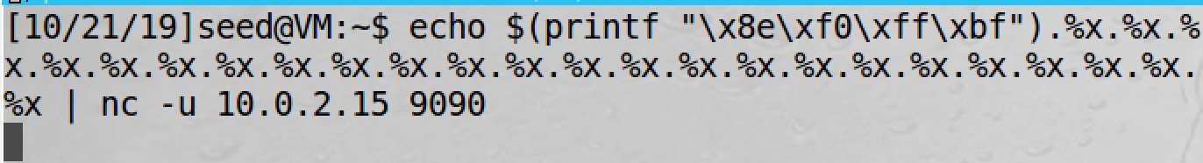

Distance between (1) to (2) is 23*4 bytes = 92 bytes.

When we print out the addresses using %x, one address must be getting printed out twice.





Hence, the buffer denoted by (3) is stored at memory address 0xbffff0d0.

Now, we know the distance between (1) and (3), we can find the memory address at (1) i.e., 0xbffff0d0 – 5c = 0xbffff074

The memory locations are:  
(1) – 0xBFFFF074  
(2) – 0XBFFFF08C  
(3) – 0XBFFFF0D0

**Task 3: Crash the Program**

To make a program crash we input %s until it reaches a null value (‘\0’). In this we make a pointer point to an invalid input. That is if the memory locations are outside programs allocated memory or in kernel space, segmentation fault will take place and thus our program crashes.

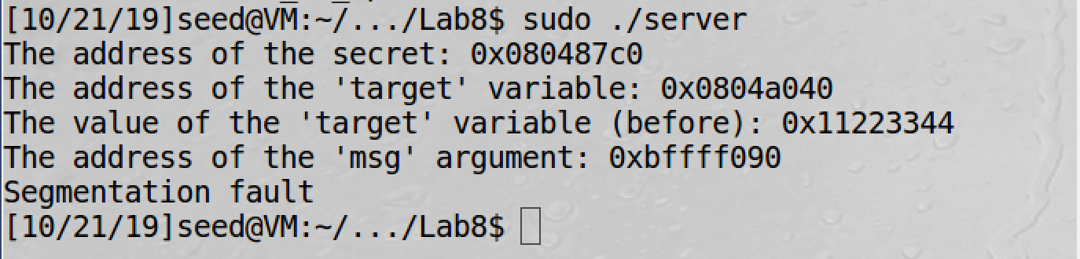



**Task 4: Print Out the Server Program’s Memory**

**Task 4.A: Stack Data**

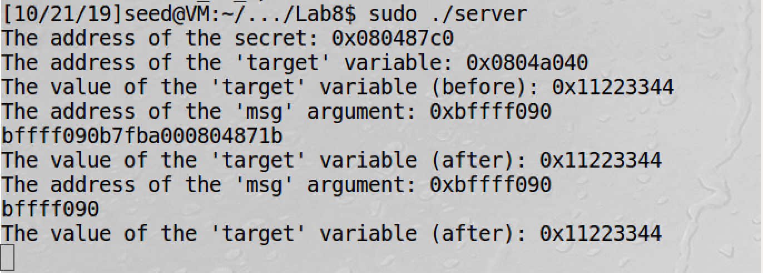

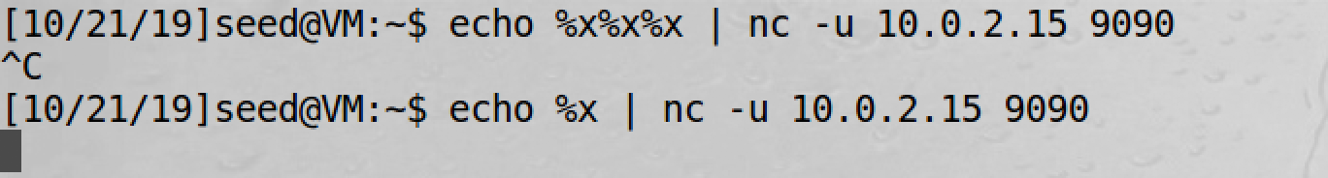

We print the data on the stack using %x format specifiers. Every %x used will advance the pointer by 4 bytes and will print out the corresponding 4 bytes.

From Task 2, we know the distance between the format string and the location where the user data is stored data is 92 bytes. Therefore, number of %x required to advance the ap to user data is 92/4 = 23.

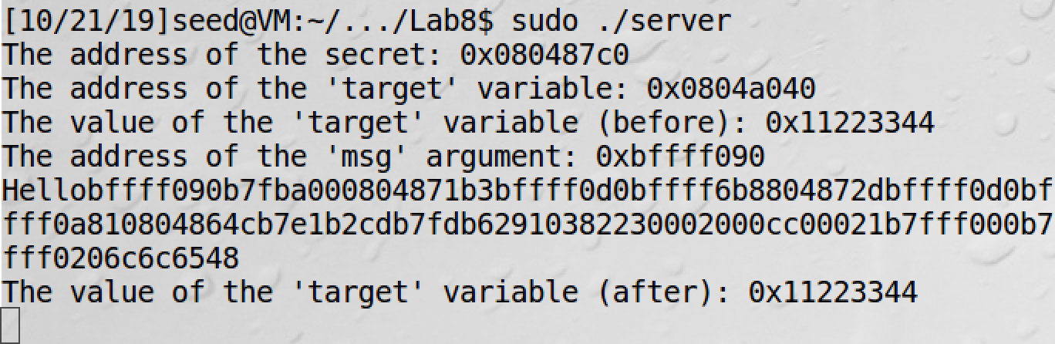

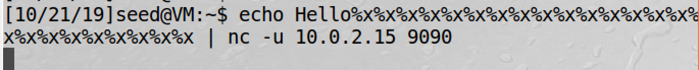

Since we want the server program to print the first 4 bytes of the user input. Hence, we require 24 %x format specifiers.

**Task 4.A: Heap Data**

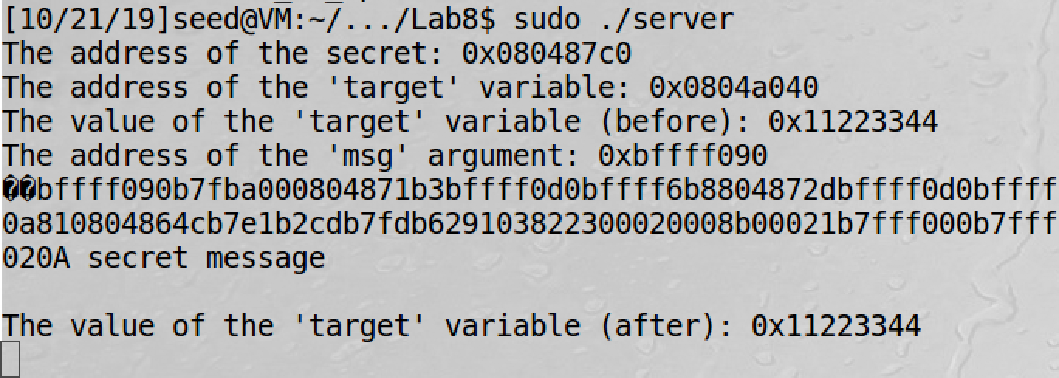

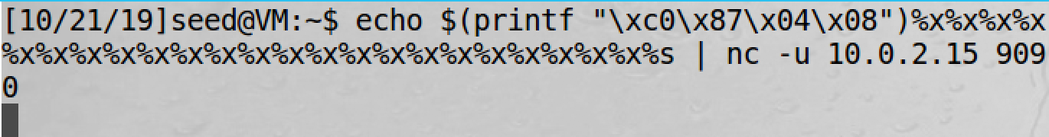

Since we don’t know the address of the secret variable. We put the target address in the beginning such that it goes to the user input. We use 23 %x and a %s to read the data from that address. Hence we obtain the contents of the secret variable and it is printed out.

**Task 5: Change the Server Program’s Memory**

**Task 5.A: Change the value to a different value**

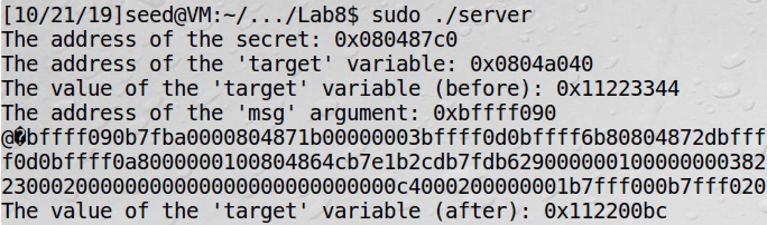



We can change the value stored in buffer using %n which writes the number of characters printed by the printf statement. Here target is 11223344. Before writing to target it prints out 4 bytes of address, then 23 * 8 for %x. Hence, 4 + (23*8) = bc and %hn writes only 2 bytes. Therefore, the variable changes to 112200bc.

**Task 5.B: Change the value to 0x500**

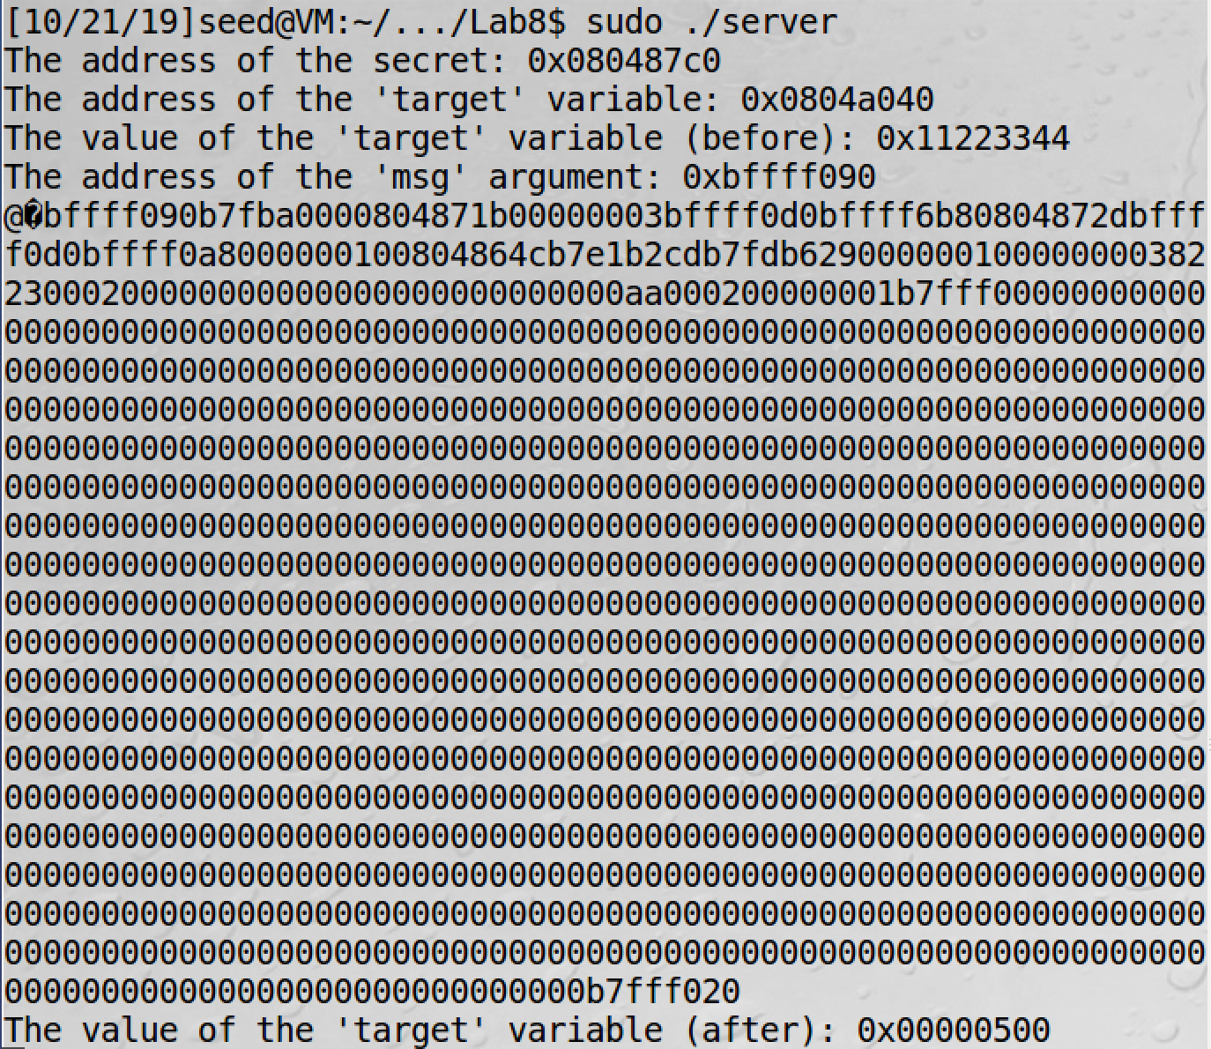

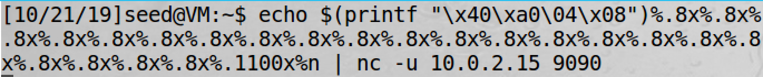

0x500 is 1280 in decimal. We have to replace 23rd %x by a value w. That is, 4 + 22*8 + w = 1280. By calculating we get w = 1100. We add a %n after the w which will then change the bytes in target variable.

**Task 5.C: Change the value to 0XFF990000**

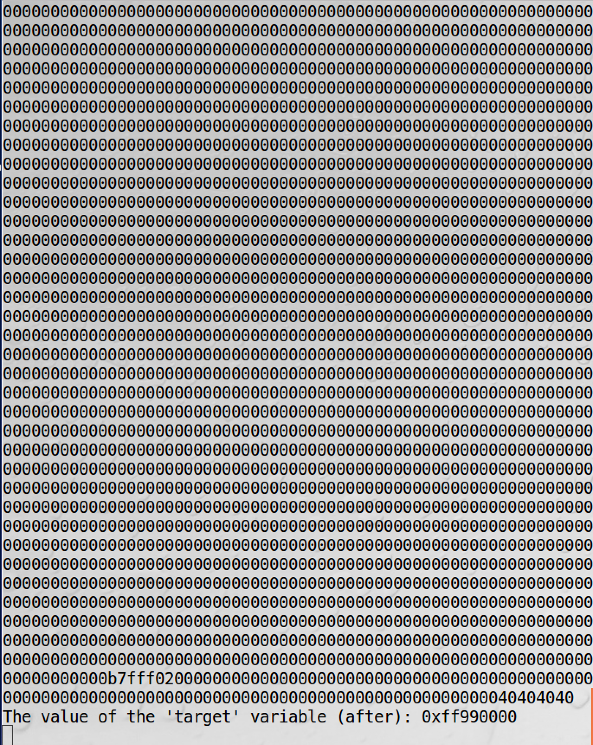

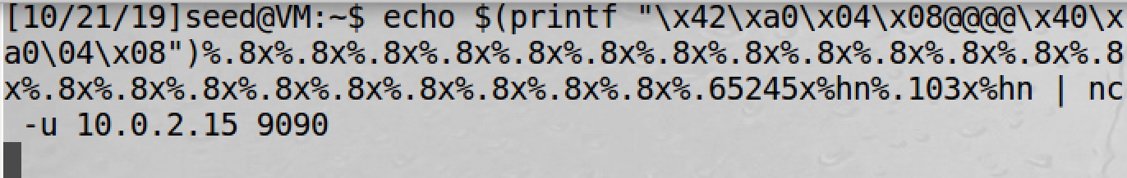

We change 2 bytes at a time using %hn. We take target address + 2 and target address separate it by @@@@. 0xff99 in decimal is 65433. Therefore, it is 12 + 22*8 + w = 65433. We get w = 65245 which will be the 23rd %x value followed by %hn which will write ff99 to the higher address 0x08044042. To get 0000 we reset the counter of %n. this is obtained by t = 103 which will be the 23rd %x value followed by %hn which will write the value 0000 to the second address 0x08044040.

**Task 6: Inject Malicious Code into the Server Program**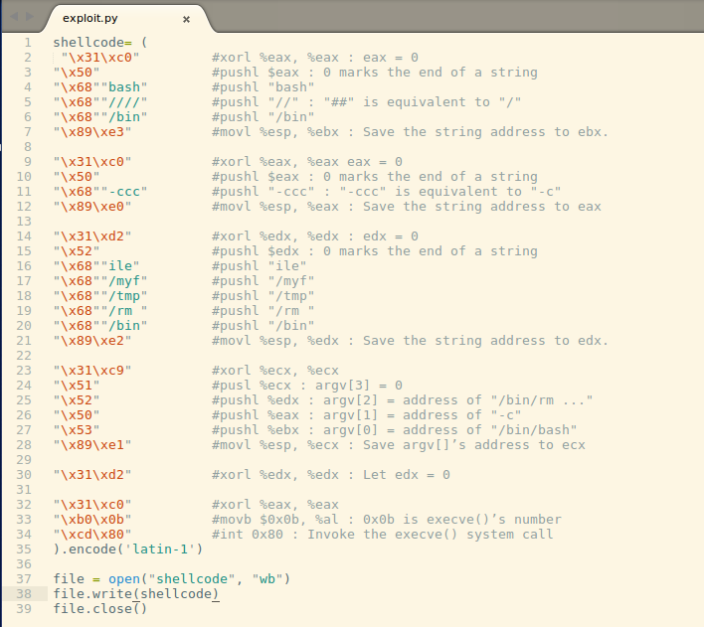

The python code writes the shellcode to remove the file into file named shellcode in binary format.

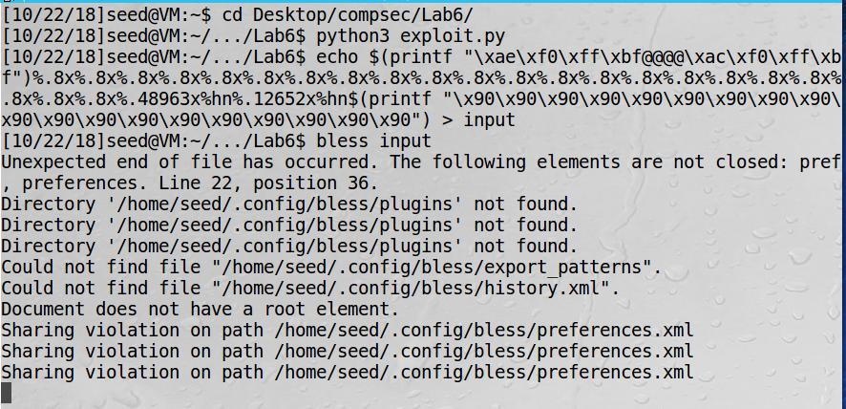

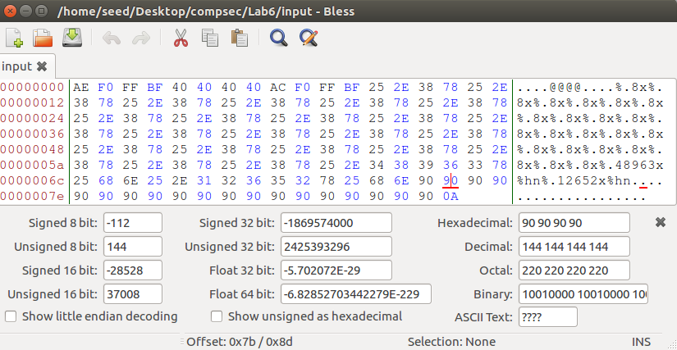

We calculate the address of the malicious code to be used in format string using the offset of NOP. We can obtain it using the bless to see the input file.  
Address = bffff0f0 + offset of NOP (0x7b) taking the second 90 hex value = address of malicious code which is bffff16b

Format String:  
We split the return address we obtain in task 2 pt 2. We use it as bffff0ae and bffff0ac. Then we need a number to write to bffff0ae using %n. Here, bfff in decimal is 49151 then we calculate the value w by, 12 + 22*8 + 3 = 49151. W = 48963. To calculate the value to write into bffffoac 49151 + t = f16b. t = 12652.

We notice in the bless editor for input file we have an extra character in the end 0A.

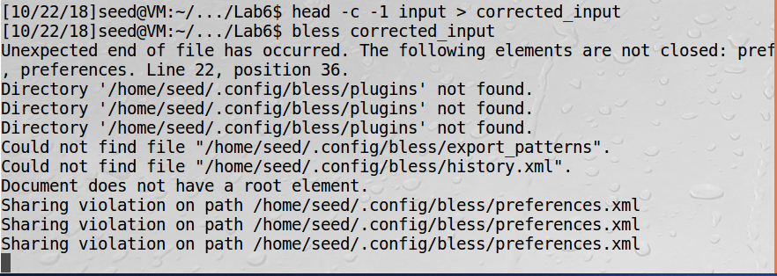

We remove the extra character as done above and store the corrected file in a new file.

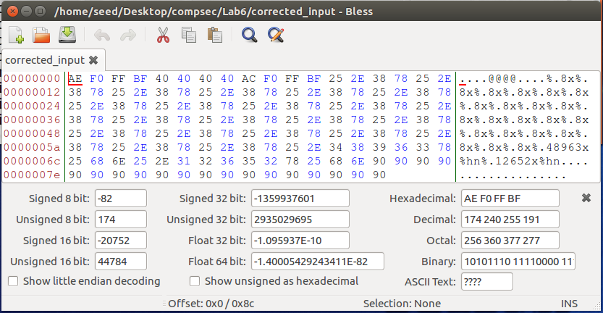

We notice in the bless editor for in the corrected file the extra character is removed.

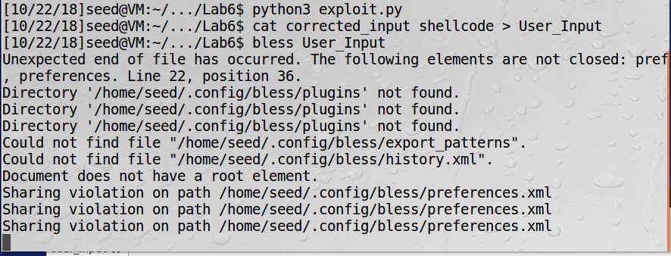

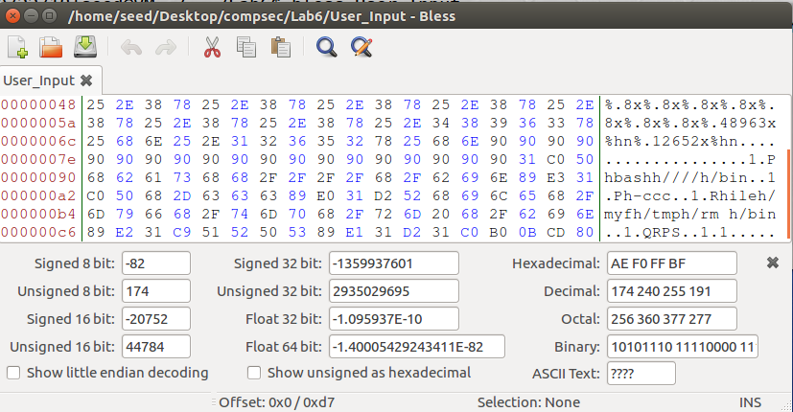

We append the shellcode file to the end of the format string and store it a user input file.

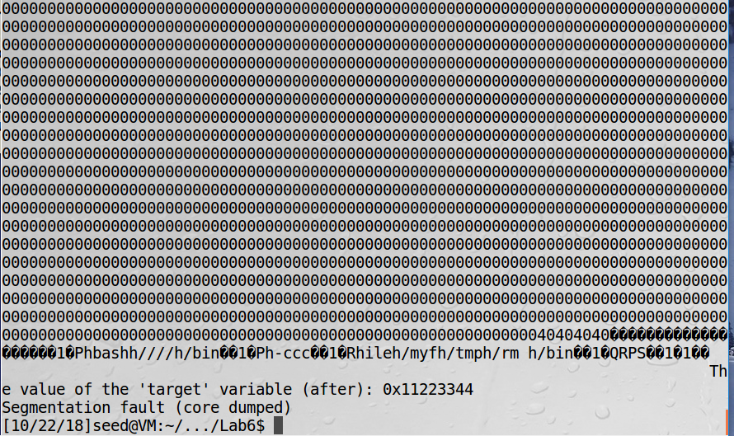

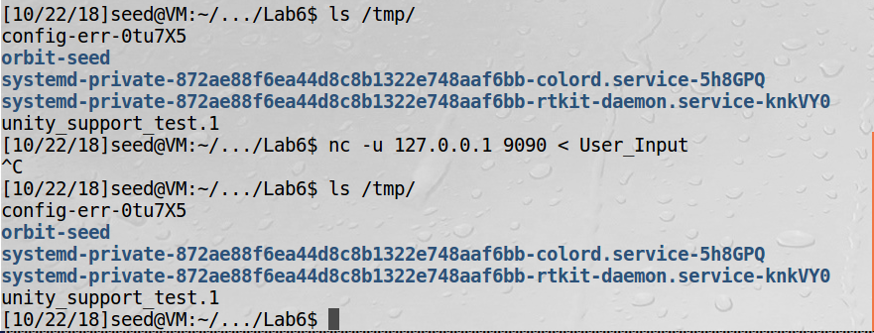

Initially when we check contents of tmp folder we see myfile document Is present the we send the format string to the server and again we check the tmp folder. We notice that the myfile decument has been removed. This means that the shellcode placed at the malicious code address was executed when the printf method return.

**Task 8: Fixing the Problem.**

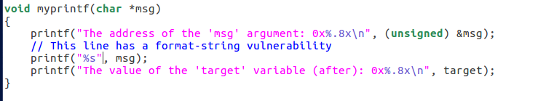

This ensures that any user input will be interpreted as a string and not as a code.

Recompiling the program, we do not see the warnings that we had got when the vulnerability was present.

The warning tells us that there is a mismatch in the number of arguments expected and the number of format specifiers. This can lead to potential Format String attacks which may lead to even remote shell access.

Now as we have fixed the vulnerability, we can attempt to crash the program using a bunch of %s format specifiers.

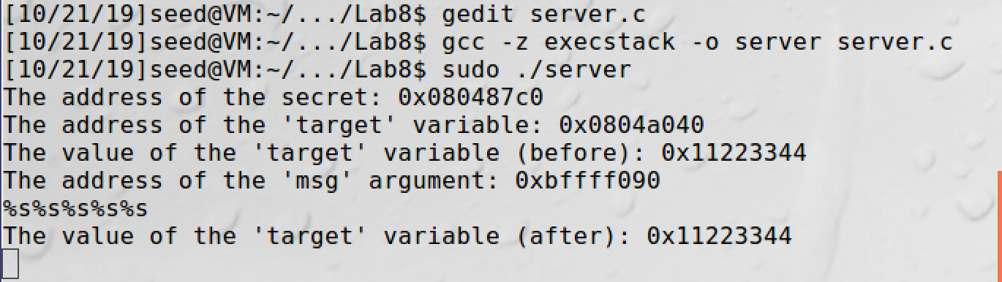

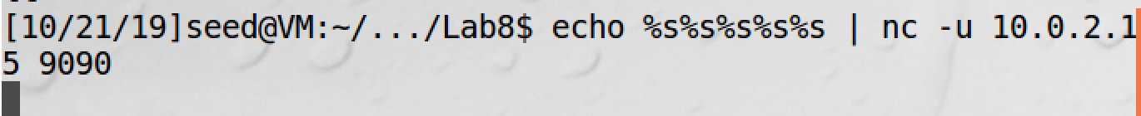

We can see that even if we provide an input which contains format specifiers, those do not get interpreted as code but as a string literal. Hence, we can see that our server program is no longer vulnerable. Additionally, we can also use address randomization and not use execstack to make the attack difficult.ß